EXPERIMENT 3

3. Write a C program to check whether a given string belongs to the language defined by a Context Free Grammar (CFG)

S → 0A1 A → 0A | 1A | ε

# AIM:

To Write a C program to check whether a given string belongs to the language defined by a Context Free Grammar (CFG)

S → 0A1 A → 0A | 1A | ε

# APPARATUS:

DEV C++

# ALGORITHM:

1. Get the input string from the user.

2. Find the length of the string.

3. Check whether all the symbols in the input are either 0 or 1. If so, print “String is valid” and go to step 4. Otherwise print “String not valid” and quit the program.

4. If the first symbol is 0 and the last symbol is 1, print “String accepted”. Otherwise, print “String not accepted”

# C PROGRAM:

#include<stdio.h>

#include<string.h>

int main(){

char s[100];

int i,flag;

int l;

printf("enter a string to check:");

scanf("%s",s);

l=strlen(s);

flag=1;

for(i=0;i<l;i++)

{

if(s[i]!='0' && s[i]!='1')

{

flag=0;

}

}

if(flag!=1)

printf("string is Not Valid\n");

if(flag==1)

{

if (s[0]=='0'&&s[l-1]=='1')

printf("string is accepted\n");

else

printf("string is Not accepted\n");

}

}

# OUTPUT:

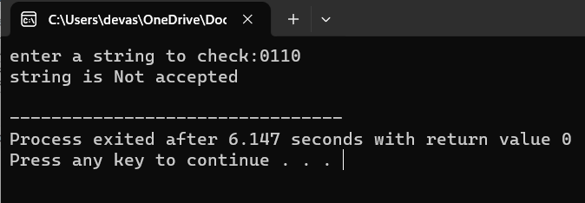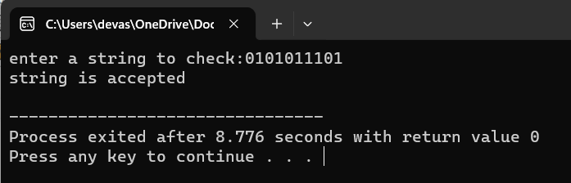

# RESULT:

Thus the c program is executed successfully and verified the string